ASSIGNMENTS 14

1).Write a command that puts the following values, in their given
order, into the salespeople table: city – San Jose, name – Blanco,
comm – NULL, cnum – 1100.

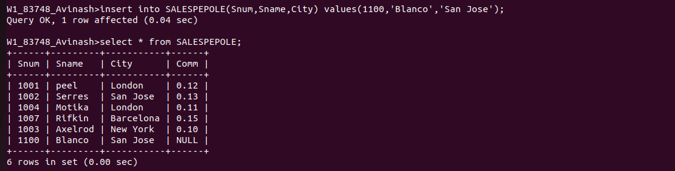

2)Write a command that removes all orders from customer Clemens
from the Orders table.
Ans.

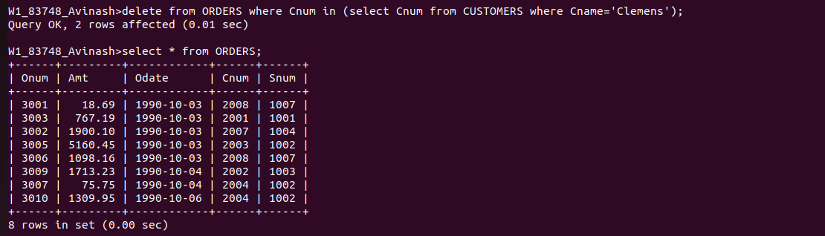

3).Write a command that increases the rating of all customers in
Rome by 100.

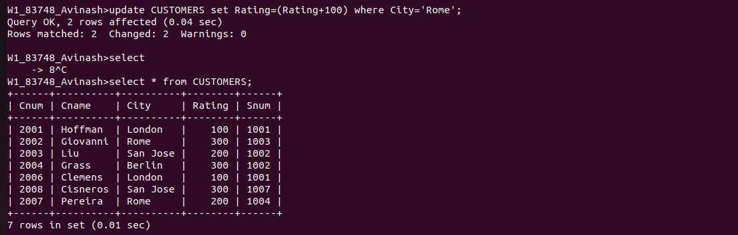

4).Salesperson Serres has left the company.Assign her customers to
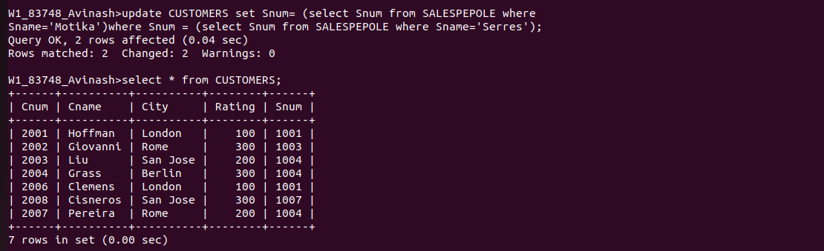
Motika.

